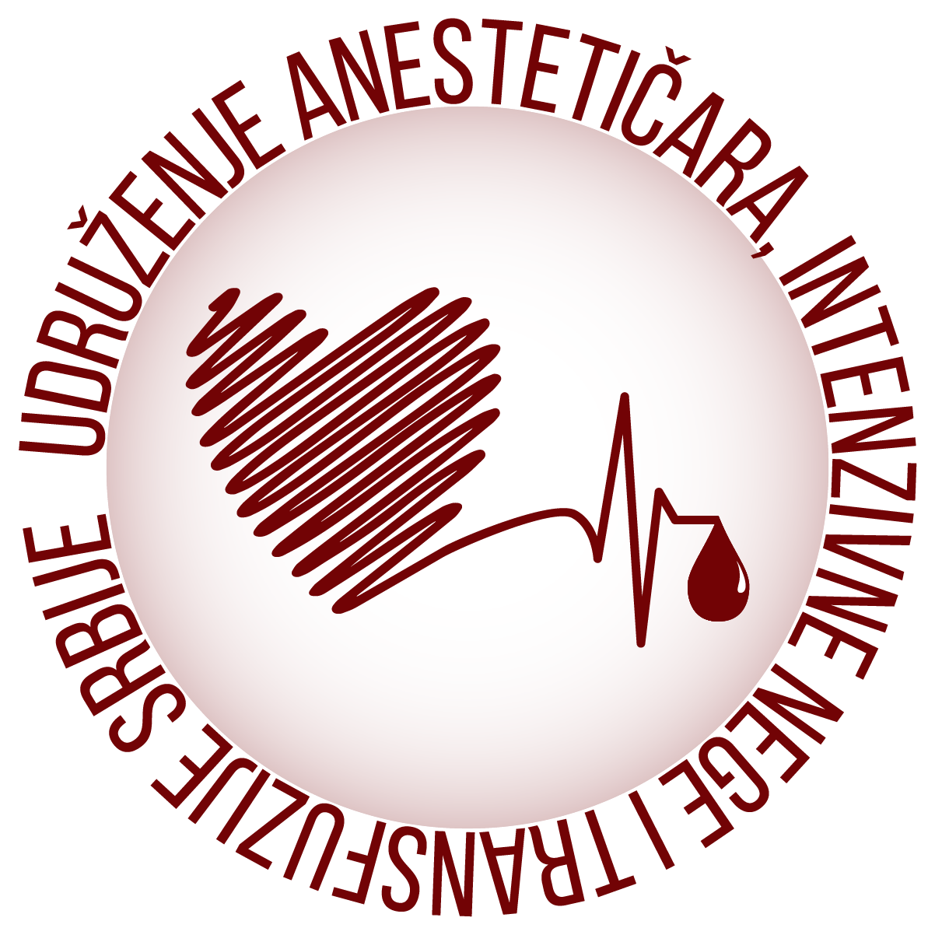Association of anesthetists intensive care and transfusion of Serbia
EXECUTIVE SUMMARY

The manner of presentation:

Orally Poster presentation Video presentation

Author:
Coauthor:
Institution:
Address:
Phone number: E–mail:
Mandatory elements of the summary are: Objective, results, conclusion, used literature,
keywords

Abstract should be sent on the following address:
e mail : udruzenje.anesteticara@gmail.com

Association of anesthetists intensive care and transfusion of Serbia
Institute for oncology and radiology
Pasterova 14, 11 000 Belgrade

